Annex D: Standard Reporting Template

Lancashire Area Team
2014/15 Patient Participation Enhanced Service – Reporting Template

Practice Name: Ilex View Medical Practice

Practice Code: P81118

Completed by: Alaina Ibbotson Date:28.03.2015

Signed on behalf of PPG: Yes see last page Date: 30.03.2015

Please confirm that the report has been published on the practice website by 31st March 2015 YES (If no, please provide further information)

- Prerequisite of Enhanced Service – Develop/Maintain a Patient Participation Group (PPG)

Does the Practice have a PPG? YES
Method of engagement with PPG: Face to face, Email, Other (please specify) Face to face and email

Number of members of PPG:4

Detail the gender mix of practice population and PPG:  % Male Female  Practice 51% 49%  PRG 75% 25% | Detail of age mix of practice population and PPG:  <16 5 - 14 15-44 45-64 65-74 75-84 85 +  Practice 523 870 2922 1732 566 294 114  PRG 1 3
Detail the ethnic background of your practice population and PRG:

 | White |  |  |  | Mixed/ multiple ethnic groups
 | British | Irish | Gypsy or Irish traveller | Other white | White &black Caribbean | White &black African | White &Asian | Other mixed
Practice | 4019 | 18 |  | 67 |  |  |  | 12
PRG | 4

 | Asian/Asian British |  |  |  |  | Black/African/Caribbean/Black British |  |  | Other
 | Indian | Pakistani | Bangladeshi | Chinese | Other  Asian | African | Caribbean | Other Black | Arab | Any other
Practice | 46 | 266 | 1286 | 8 | 14 | 2 | 4 | 2 |  | 1420
PRG

Describe steps taken to ensure that the PPG is representative of the practice population in terms of gender, age and ethnic background and other members of the practice population:

Are there any specific characteristics of your practice population which means that other groups should be included in the PPG?
e.g. a large student population, significant number of jobseekers, large numbers of nursing homes, or a LGBT community? YES/NO

We have around a 20% list size BME that we have unsuccessfully managed to get as part of our PPG. We have approached mosques and community groups and individual patients however no one has come forward to be part of the PPG.

- Review of patient feedback

Outline the sources of feedback that were reviewed during the year: We have done MSF for doctors and also a general practice questionnaire as well as Friends and Family tests and feedback through our website.

How frequently were these reviewed with the PRG? We have met 6 monthly but email updates if needed.

- Action plan priority areas and implementation

Priority area 1
Description of priority area: Access

What actions were taken to address the priority? Along with support from the PLG we have altered the appointment booking system to allow more pre bookable appointments. We were going to review this in April however due to time constraints and data we are going to review the impact this has had on access in April.

Result of actions and impact on patients and carers (including how publicised): We will be putting out another questionnaire to ask patients again regarding access to see if the new booking system has impacted on the access issues we had from the last questionnaire.

Priority area 2
Description of priority area: Telephone appointments

What actions were taken to address the priority? The PLG rose that often people can be dealt with on the phone if it is to discuss blood results, medication queries and investigation results. This would free up GP appointments and also be more convenient for the patient.

Result of actions and impact on patients and carers (including how publicised): We have added two telephone consultation onto the end of each GP session so patients can pre book these for certain things. This has been very successful and has proved a positive step for patients after the results of a short data collection around satisfaction.

Priority area 3
Description of priority area: Text message reminders

What actions were taken to address the priority? We discussed the issue of DNAs at meetings and how we could try and reduce these especially as we were going to start pre booking more appointments and we agreed to join MJOG and start to use that service to remind patients by text message of there appointment.

Result of actions and impact on patients and carers (including how publicised): After an audit of DNA appointments we have seen a reduction in GP and nurse pre booked appointments not attended however we still have a number of book on the day appointments not attended as we do not send text messages for those.

Progress on previous years

If you have participated in this scheme for more than one year, outline progress made on issues raised in the previous year(s):
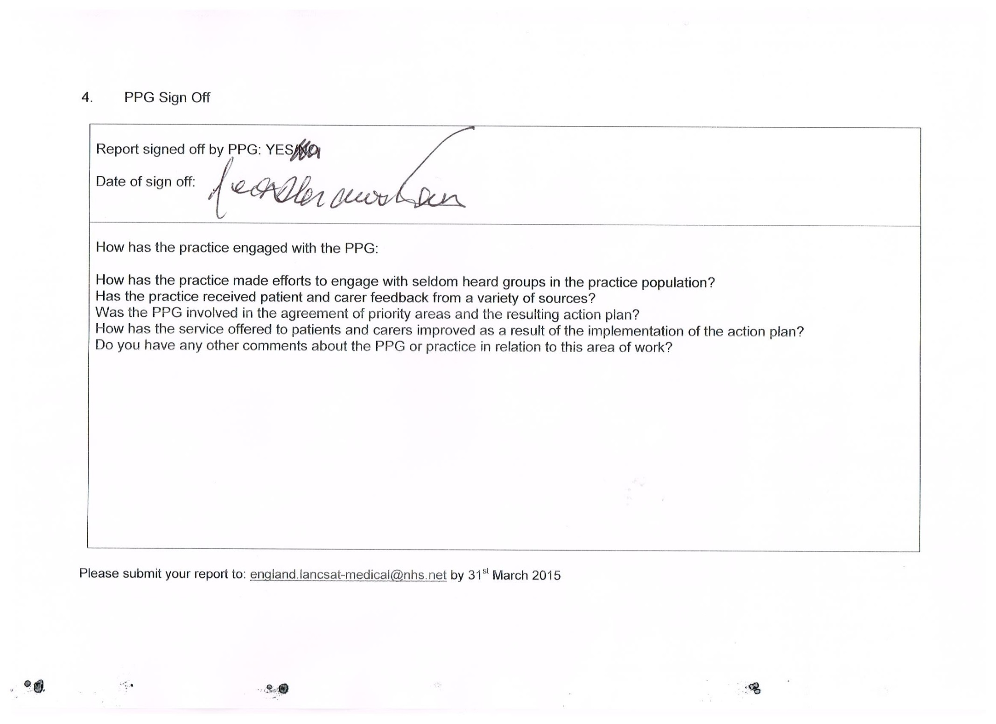
We have worked on a few projects with the PLG including access, telephone consultations with a doctor, emergency nurse appointments and confidentiality in the waiting room. Each project we have worked on has been successful and has resulted in positive outcomes for the patients. We are lucky to have a very good PLG chair that is keen to get involved in the practice and provides excellent ideas on how we can improve for the patients.
All PLG reports are published on our website and information is also in the waiting room. We are always open to new members and people can sign up through the website or by speaking to reception.

